Section 1. Project Management Plan

1.1 Team Management
Moonlight WMS was run by a well-organized, team-based approach. Right from the start of the project, the tasks and responsibilities were assigned clearly so each member not only knew what they had to do individually but also understood how their part contributes to the whole system.

It made the team stay on target, decrease duplicate efforts, and ensure that the project stays well-organized throughout the development phase.Team members were: Anil Budthapa, Anil KC, Diwas Phuyal, Thi Phuong Thanh Bui, Ashima Basnet, Marc, and Ritesh. Anil Budthapa took charge as the project manager and was a backend developer also. Anil KC was involved both as a frontend developer and a test engineer. Diwas Phuyal was responsible for frontend development and quality assurance person. Thi Phuong Thanh Bui helped with DevOps and deployment engineering. Ashima Basnet was a backend developer. Marc's work was centered on the AI assistant chatbot feature.

Ritesh was the database administrator and handled anything related to the database.The main tool for team communication was WhatsApp. The team used the group chat for daily updates, quick discussions, meeting arrangement, sharing screenshots, reporting bugs, and discussing lecturer feedback. This enabled the members to solve problems promptly including database issues, frontend errors, API hiccups, deployment difficulties, and GitHub workflow questions.However, GitHub served as the official collaboration platform.

It was the place where project files were kept, source code was managed, tasks were tracked, and development history was preserved. The project was handled within the MEL15-Avengers GitHub organisation, which was the central repository for assignment-related materials.

GitHub organisation link:
https://github.com/MEL15-Avengers
GitHub repositories link:
https://github.com/orgs/MEL15-Avengers/repositories
The organisation contained separate repositories such as Assignment3, Assignment4, and Assignment5. This helped the team separate different stages of project work instead of mixing everything into one unstructured repository.
Assignment3 repository link:
https://github.com/MEL15-Avengers/Assignment3
Assignment4 repository link:
https://github.com/MEL15-Avengers/Assignment4
Assignment5 repository link:
https://github.com/MEL15-Avengers/Assignment5
This team management approach helped the group stay organised and accountable. WhatsApp supported quick communication, while GitHub provided a formal record of repositories, issues, tasks, and progress. Together, these tools allowed the team to manage the Moonlight WMS project in a structured and professional way.
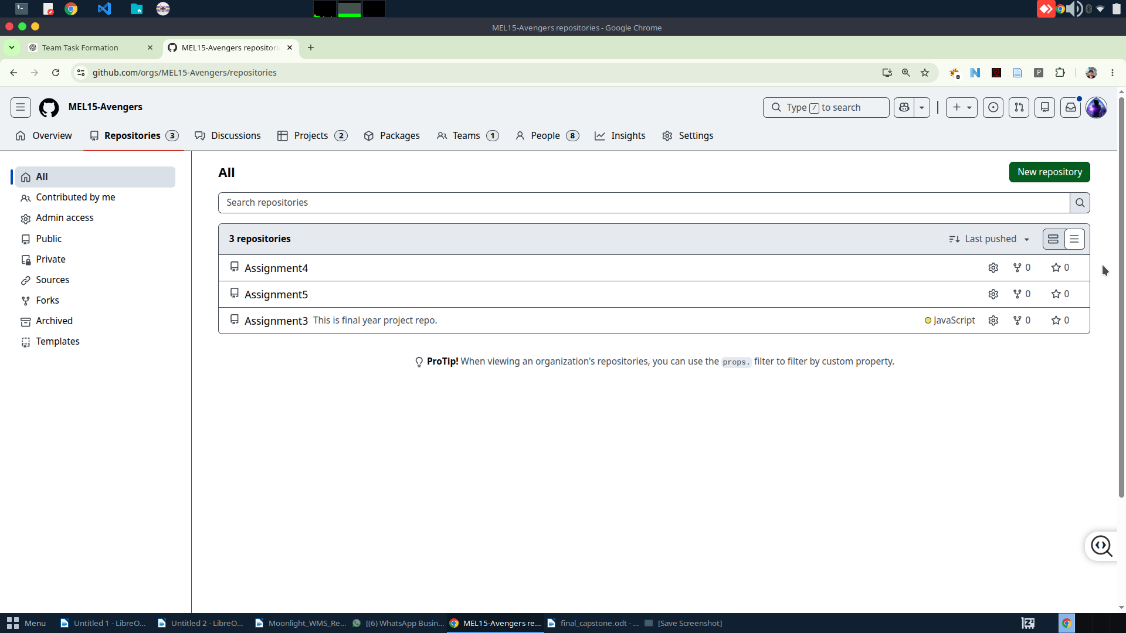Figure 1: MEL15-Avengers GitHub organisation showing Assignment3, Assignment4, and Assignment5 repositories
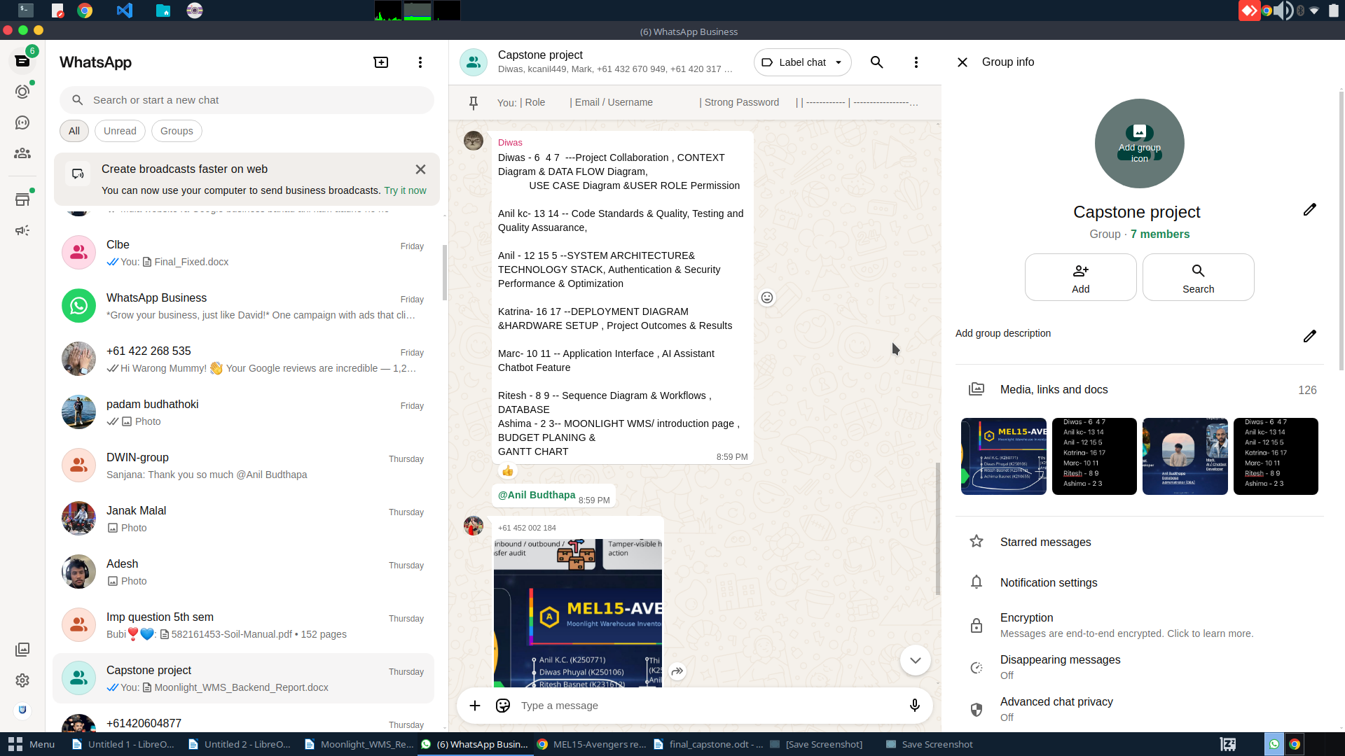Figure 2: WhatsApp group communication showing project discussion, updates, or shared screenshots

